1. **Create a directory "exercise" inside your home directory and create nested(dir1/dir2/dir3) directory structure inside "exercise" with single command.**

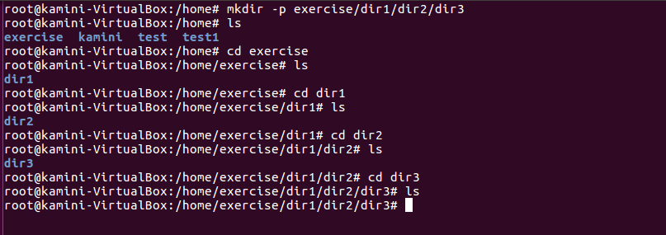

1. **Create two empty files inside dir2: emptyFile1, emptyFile2 in single command**

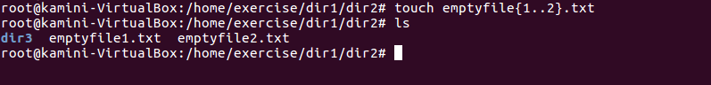

1. **Create one file file.txt containing text "hello world" and save it.**

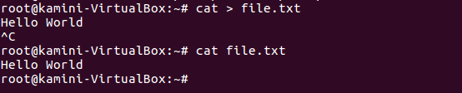

1. **Find a "passwd" file using find command inside /etc. copy this files as passwd_copy and then rename this file as passwd_backup.**

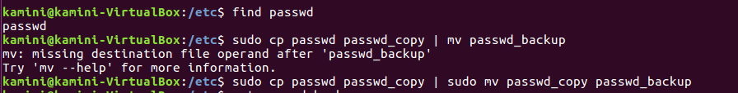

1. **Try reading passwd_backup file in multiple tools: less,more,cat,strings etc and find the difference in their usage.**

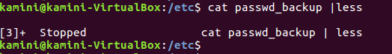

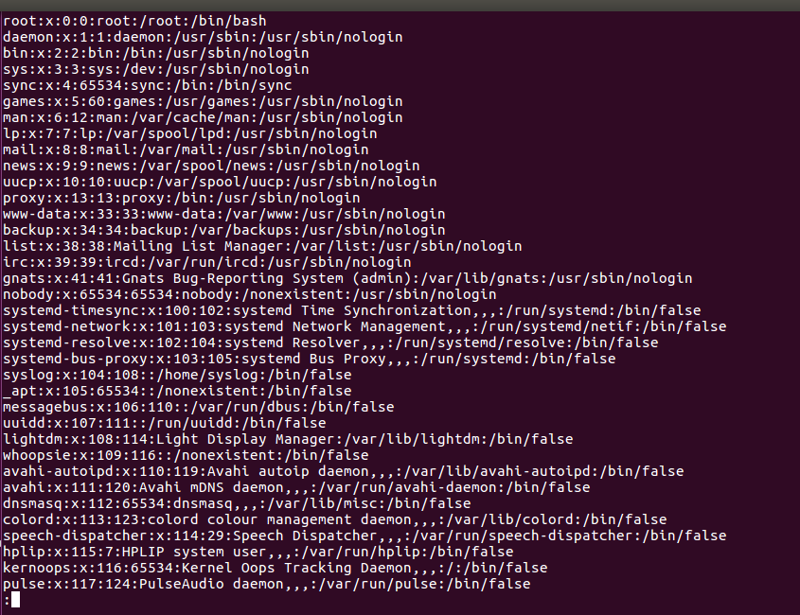

**------------------------------------MORE-----------------------------------------**

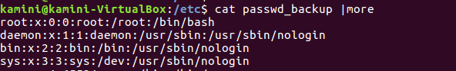

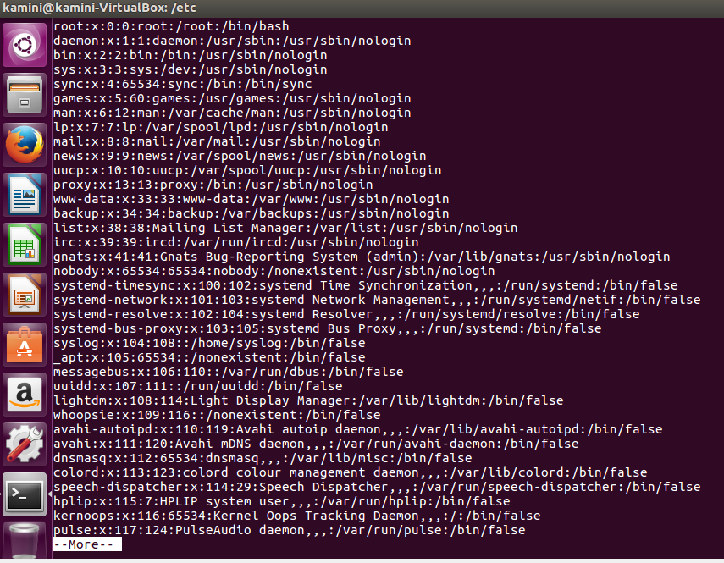

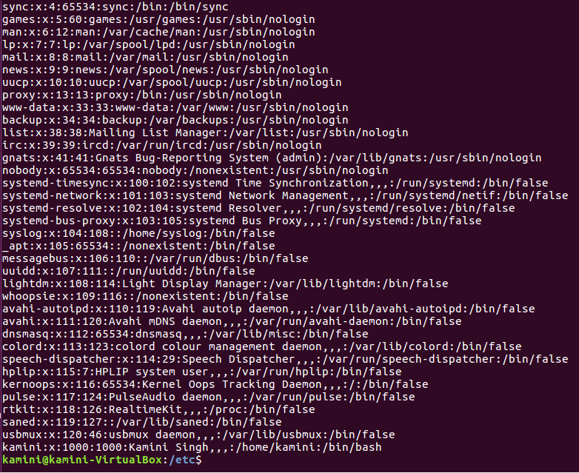

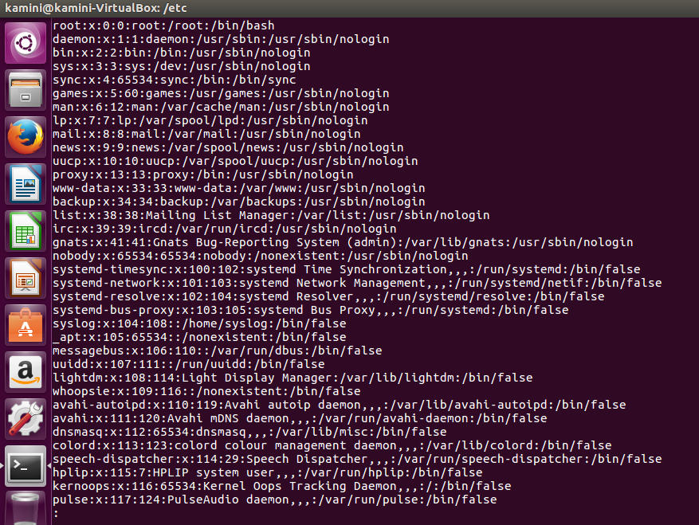

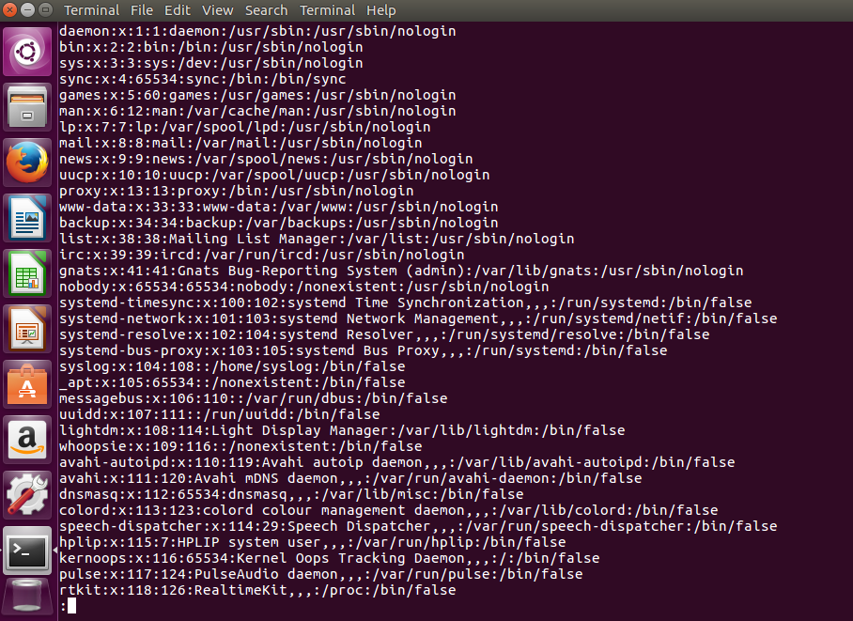

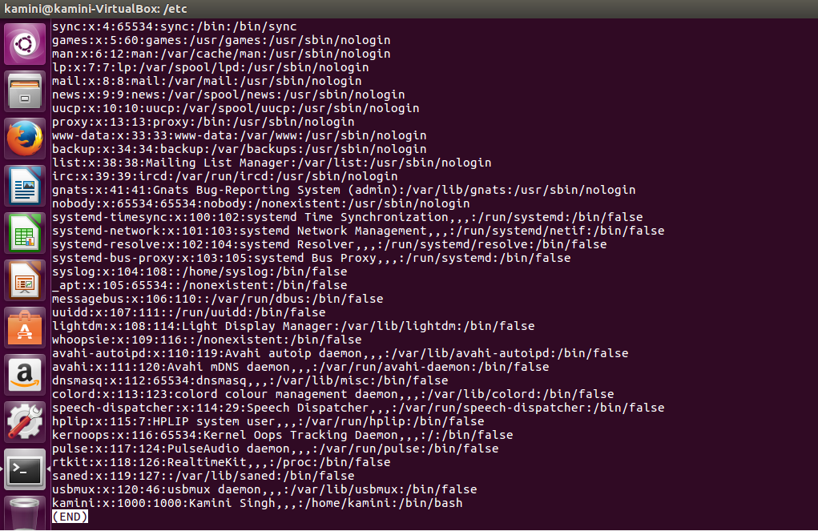

**------------------------------------------cat-----------------------------------------------------**

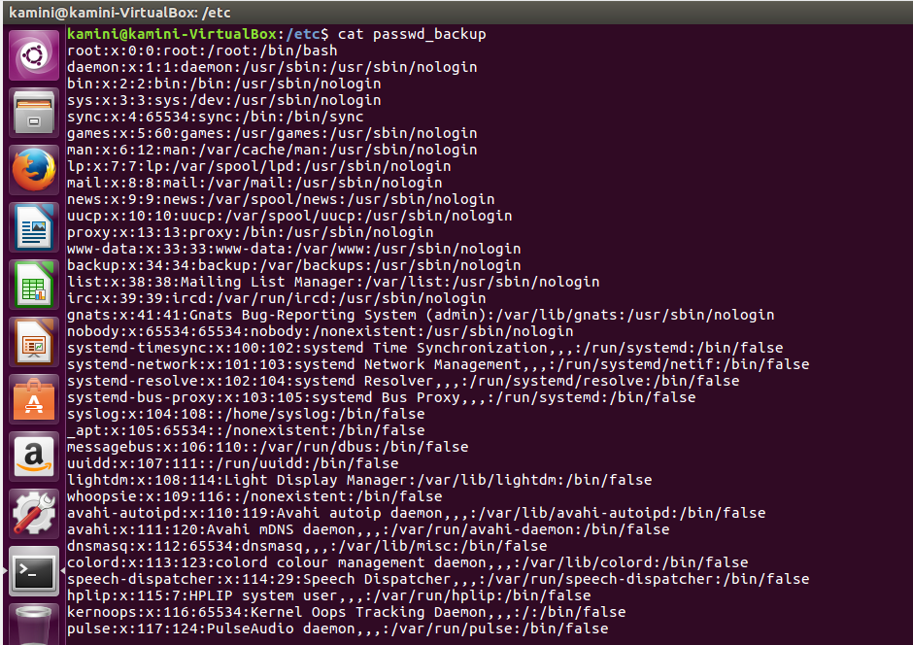

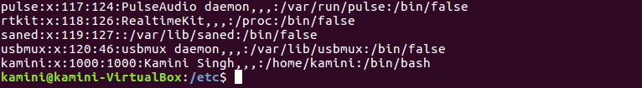

**--------------------strings-----------------------------------------------------------**

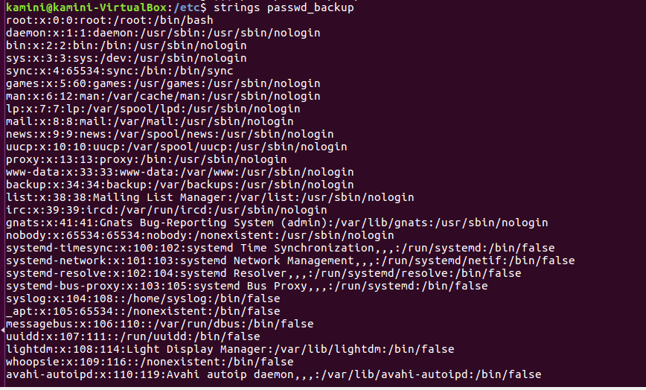

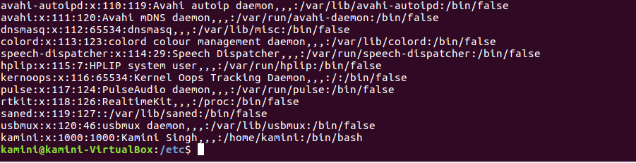

1. **Find out the number of line in password_backup containing "/bin/false".**



1. **Get the first 5 lines of a file “password_backup” and  Redirect the output of the above commands into file "output".**

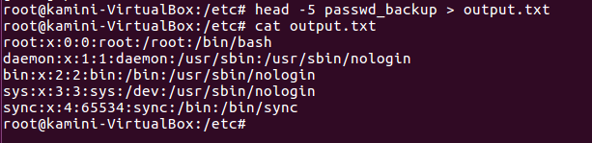

1. **Create a "test" user,create its password and find out its uid and gid.**

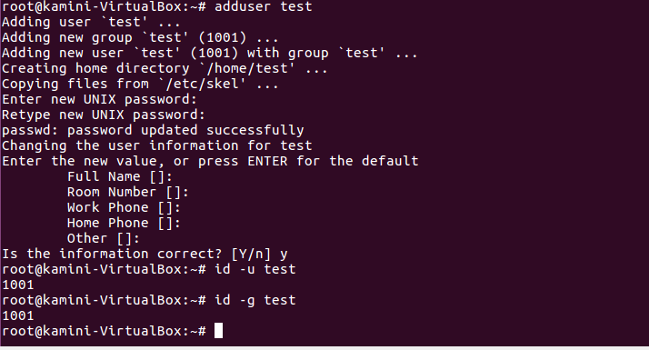

1. **Change the timestamp of  emptyFile1,emptyFile2 which are exist in dir2**

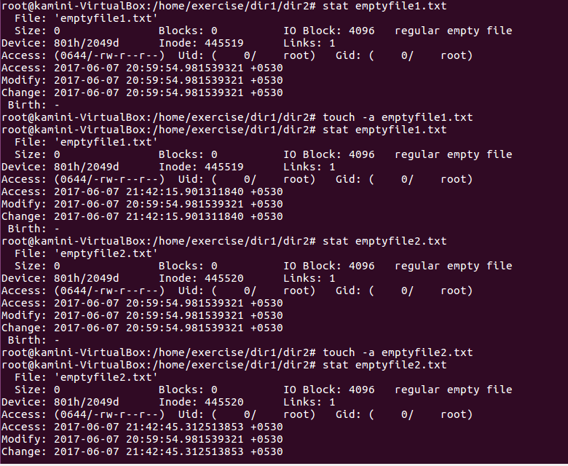

1. **Login as test user and edit the "output" file created above. Since the permission wont allow you to save the changes. Configure such that test user can edit it.**

* **Add group owner of the "output" file as the secondary group of testuser and check/change the "output" file permission if it is editable by group. Once done revert the changes**

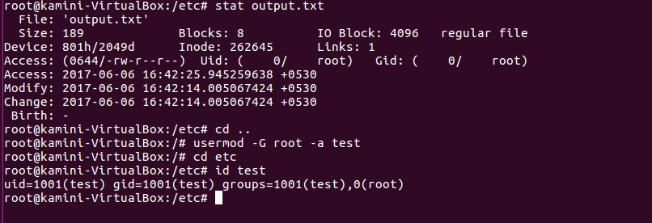

* **Make the file editable to the world so that test user can access it. Revert the changes after verification**

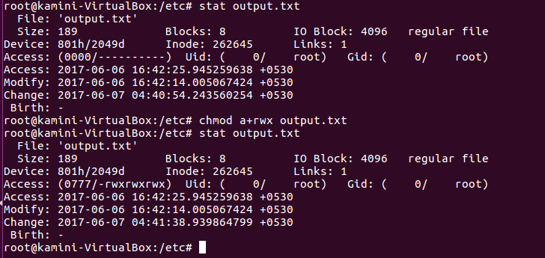

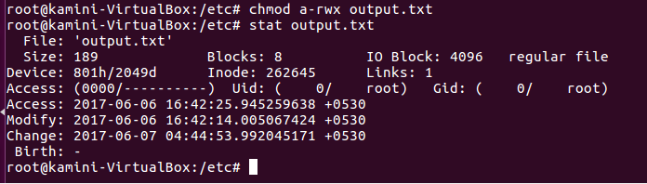

* **Change the ownership to edit the file.**

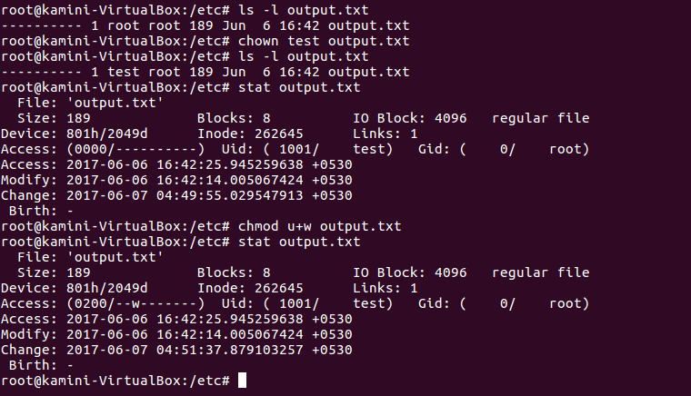

1. **Create alias with your name so that it creates a file as "/tmp/aliastesting".**

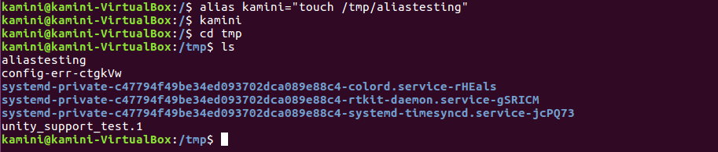

1. **Edit ~/.bashrc file such that when you change to "test" user it should clear the screen and print "Welcome".**

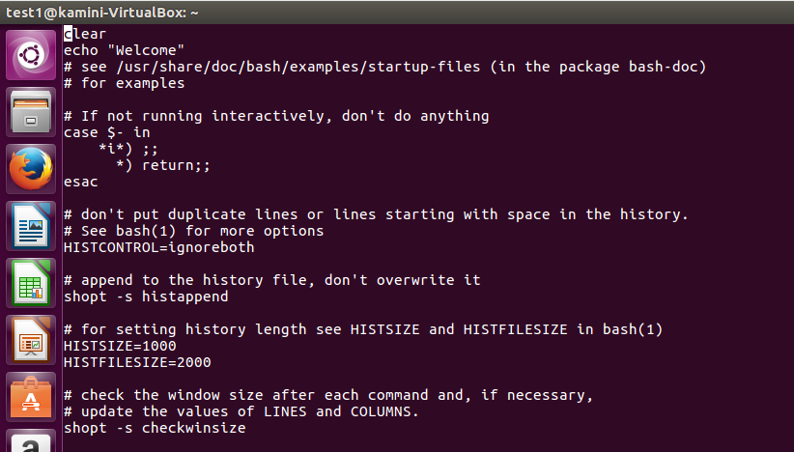

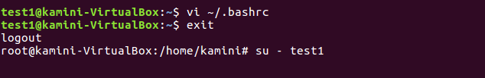

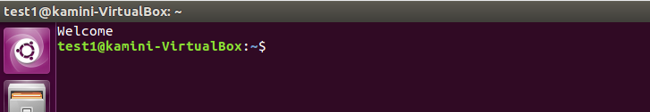

1. **Install “zip” package.**

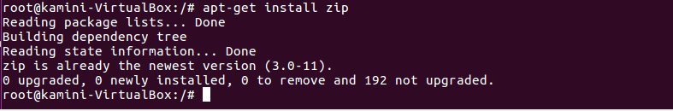

1. **Compress "output" and "password_backup" files into a tar ball. List the files present inside the tar created.**

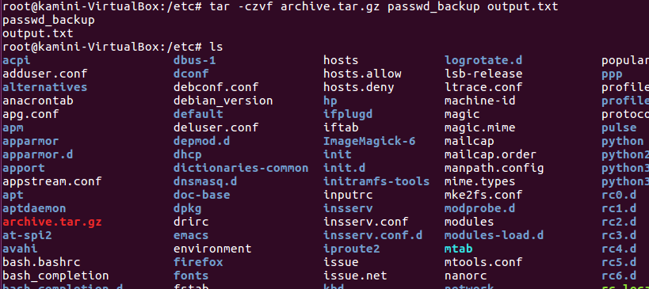

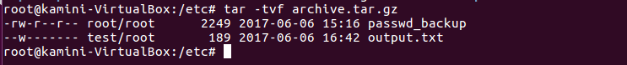

1. **scp this file to test user**

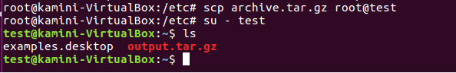

1. **Unzip this tar bar by logging into the remote server**

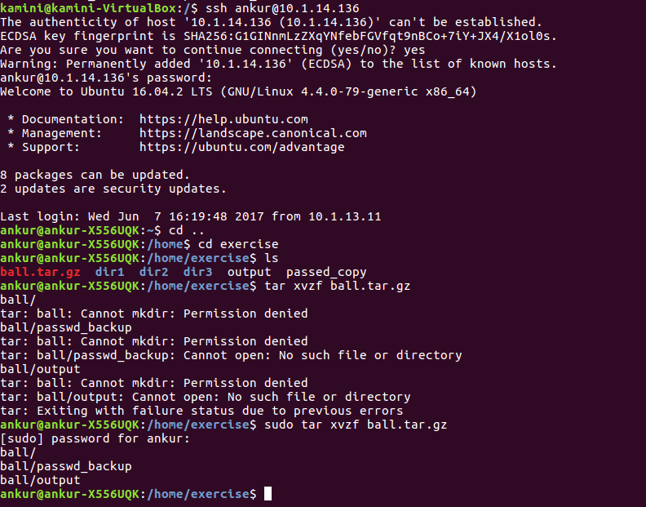

1. **Download any image from web and move to desktop**

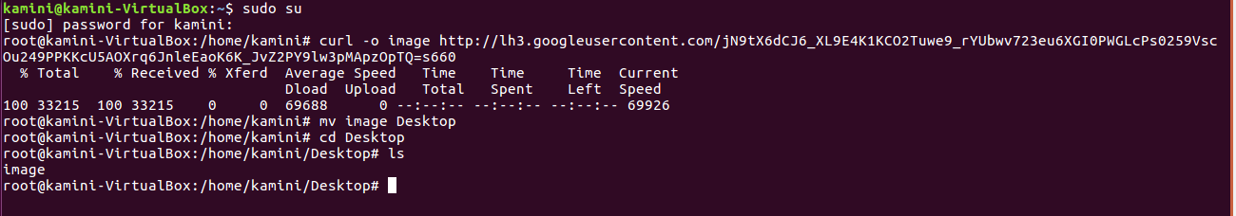

1. **How to get help of commands usages.**



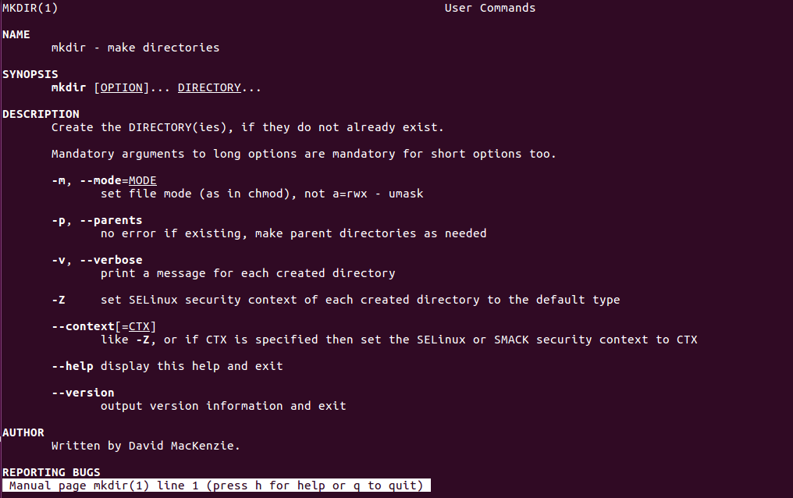

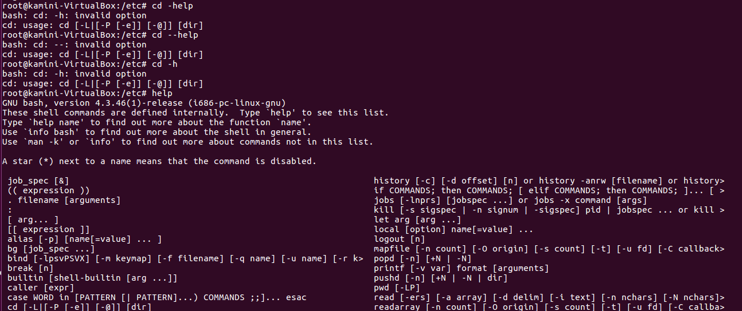

1. **Create a symlink of /etc/services into /tmp/ports-info**



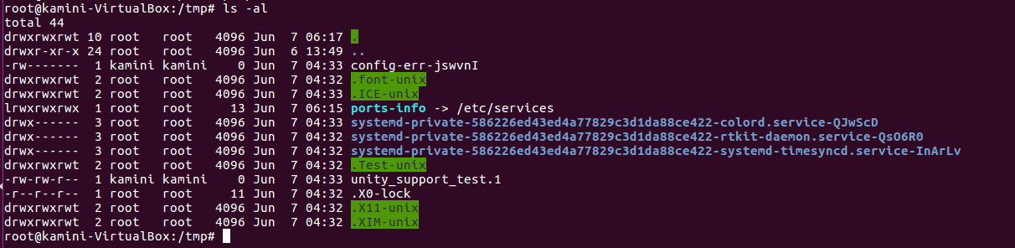

1. **You are appointed as a Software/DevOps Engineer in ABC media services. On your first day you need to troubleshoot a problem. There is a command “xyz” somewhere installed in that linux system. But as a new joinee you do not have any idea about where is that Installed. How can you check that?**

